VISOKA ŠKOLA STRUKOVNIH STUDIJA

ZA INFORMACIONE I KOMUNIKACIONE TEHNOLOGIJE

INTERNET TEHNOLOGIJE

**IGRICE “Mice” I “Isolation” U WEB BROWSERU**

Z a v r š n i r a d

**Mentor: Student:**

Dr Nenad Kojić, dipl. inž. Nikola Nedeljković 2/17

Beograd, 2020.

VISOKA ŠKOLA STRUKOVNIH STUDIJA

ZA INFORMACIONE I KOMUNIKACIONE TEHNOLOGIJE

INTERNET TEHNOLOGIJE

Predmet: Web programiranje 2

Tema: **Igrice “Mice” i “Isolation”**

**Ocena ___ ( )**

**Članovi komisije:**

**______________________**

**______________________**

**______________________**

Sadržaj

1. UVOD 5

2. RADNO OKRUŽENJE 6

3. ORGANIZACIJA 7

3.1 Blok šema 7

3.1.1 Početna stranica 8

3.1.2 Inicijalni izgled “Mica” 8

3.1.3. Pravila igre “Mica” 9

3.1.4 Izgled nakon postavljanja svih figura 9

3.1.5 Završetak igre “Mica” 10

3.1.6. Obaveštenje o greški u igri “Mica” 10

3.1.7 Inicijalni izgled “Isolation” 11

3.1.8 Pravila igre “Isolation” 11

3.1.9 Završetak igre “Isolation” 12

3.1.10 Obaveštenje o greški u igri “Isolation” 12

4. KODOVI 13

4.1 Organizacija: 13

4.2 HTML 14

4.2.1 index.html 14

4.2.2 mica.html 15

4.2.3 isola.html 17

4.3 CSS 20

4.3.1 style.css 20

4.3.2. messages.css 21

4.3.3. mica.css 24

4.3.4. isola.css 26

4.4 JAVASCRIPT 28

4.3.1 messages.js 28

4.3.2 mica.js 29

4.3.3 isola.js 33

6. ZAKLJUČAK 35

7. LITERATURA 36

# 1. UVOD

Web sajt, kojem je neformalno dodeljeno ime RarOks Games je web sajt namenjem igranju nekih od najpopularnijih retro igara u Vašem omiljenom Internet pregledaču. “Mice” su jedne od najstarijih i najomiljenih igara na table, dok se “Isolation” igrao najčešće na papiru. Ulaskom Interneta možemo i ove klasične igre pridodati kolekciji online igara. Projekat je inspirisan velikom ljubavlji ka igrama, a pogotovu retro igricama.

Stranica će biti dizajnirana tako da je lako ponovno igranje a i izbor druge igre. Igre će biti kreirane tako da je potrebno prisustvo oba igrača, jer samim uvođenjem online traženja protivnika, gubi se sama čar lokalnog igranja sa prijateljem.

Odabir igre se vrši sa početne stranice. U slučaju obe igre prvi potez ima plavi (Igrač 1) kao što je I u prvim igrama bilo korišćeno, kao i zbog osoba sa daltonizmom.

Igra “Mica” počinje sa praznom tablom. Igrači naizmenično postavljaju svoje figure na prazna polja. Ako neki od igrača uspe da postavi tri u redu, horizontalno ili vertikalno, oni onda sklanjaju jednu protivničku figuru sa polja i iz igre, s tim što se ne sme uzimati protivnička figura koja već čini tri-u-redu, osim ako nije jedini moguće izbor. Nakon što su postavljene po 9 figure od strane oba igrača kreće druga faza igra. U drugoj fazi igrači, takođe naizmenično, pomeraju svoje figure na susedna, nezauzeta polja. Ne može se preskakati druge figure. Ovim, igrači pokušavaju da ponovo dovedu do tri-u-redu kako bi uklonili protivničku figuru iz igre. Kada jedan igrač ostane samo sa tri figure, onda svoje figure može pomeriti na bilo koje nezauzeto mesto.

U igri “Islolation” igračima su figure već postavljene na polja, prvom igraču na srednje polje u prvom redu, a drugom igraču na srednje polje poslednejg reda. Igrači onda naizmenično pomeraju svoje figure u bilo kom pravcu, po jedno polje, bilo horizontalno, vertikalno ili dijagonalno. Nakon pomeraja, mesto na kome se igrač nalazio propada iz igre. Igrač koji ostane bez mogućih poteza je izgubio.

U obe igre se u gornjem levom uglu nalazi “?” koji igrači mogu pritisnuti da bi videli pravila date igre. Klikom na “x” pravila se sklanjaju i igra se nastavlja. U zavisnosti od dizajna, podaci o trenutnom korisniku na potezu i potezu za koji se čeka se nalaze ili u samom središtu igre, kao kod mica, ili uz sredinu leve ivice ekrana. Ukoliko igrač nešto pogreši, ili odradi neku nedozvoljenu radnju, iskače obaveštenje o greški. Na kraju svake igre izlazi obaveštenje o pobedniku, kao i mogućnost ponovnog igranja igre ili odlaska u glavni meni, radi izbora druge igre.

# 2. RADNO OKRUŽENJE

Pri izradi ovog projekta, korišćen je čist JavaScript za sve funkcionalnosti aplikacije. Izvršena je i podela JavaScript datoteka po onome za šta su koričćeni tako da ni jedna igra ne učitava ni jednu liniju nepotrebnog JavaScript koda. I sve funkcionalnosti sadrže svoje zasebne funkcije i promenljive. U svim mogućim situacijama primenjen je ECMA Script 6, radi lakše primene I održavanja samih igrica.

JQuery je korišćen za dohvatanje klika korisnika, i tačnog bloka na kome se taj klik desio. Za prikaz grafičkog sadržaja sajta korišćen je posebno pisan HTML5 i CSS3. Responsive je za sve uređaje sa landscape ekranom. Slika koja se koristi za pozadinu igre “Mica” je odrađena kao svg, zbog, eventualno, lakčih izmena u samom izgledu i boji.

U toku razvoja aplikacije, korišćena su sledeća razvojna okruženja: “Atom“ i “Notepad++”.

# 3. ORGANIZACIJA

## 3.1 Blok šema

Na slici 1. prikazana je organizaciona šema stranica web aplikacije. Imena stranica predstavljaju imena posebnih stranica igara ili početne stranice. Pristup različitim stranicama je neograničen, tako da svaki neautorizovani korisnik može pristupiti svakoj igri.

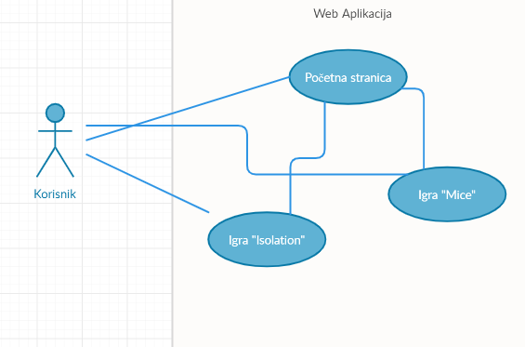

Slika 1 – Organizaciona struktura sajta

### 3.1.1 Početna stranica

Na slici 2. je prikazana inicijalna stranica koja se prikazuje kada korisnik pristupi aplikaciji. Na ovoj stranici je moguće izabrati željenu igru kao i posetiti stranicu o autoru.

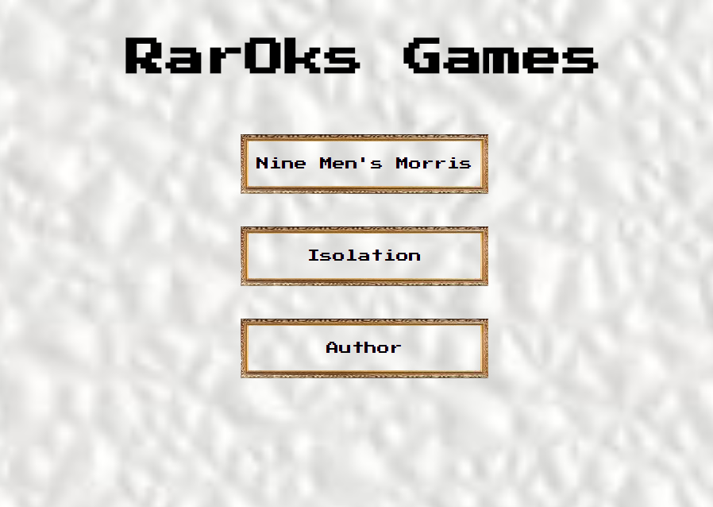

Slika 2 – Početna stranica

### 3.1.2 Inicijalni izgled “Mica”

Na slici 3. je prikazan inicijalni izgled igre “Mica” nakon prvog pokretanja korisnika. Opis za dalje detalje o igri se nalazi u centralnom delu stranice, koji se popunjava JavaScript-om nakon potpunog učitavanja stranice. Klikom na dugme “?” korisniku se ispisuju pravila igre i igra se trenutno pauzira.

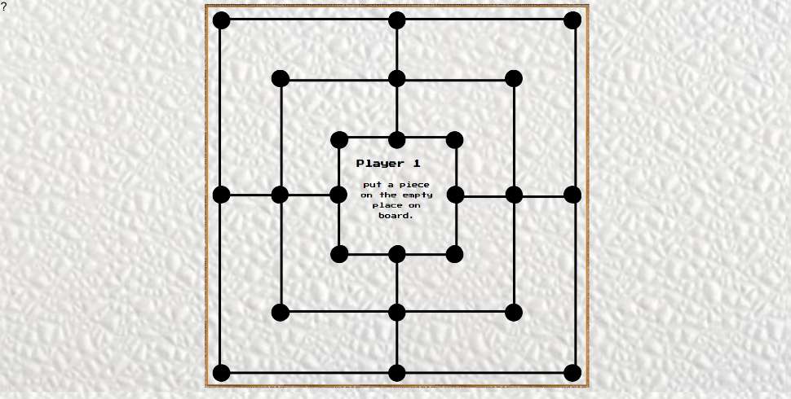

Slika 3 – Inicijalni izgled “Mica”

### 3.1.3. Pravila igre “Mica”

Na slici 4. je prikazan izgled stranice o pravilima “Mica”. Klikom na dugme “x” izlazimo iz pravila i nastavljamo igru u trenutku gde smo je ostavili pre otvaranja pravila.

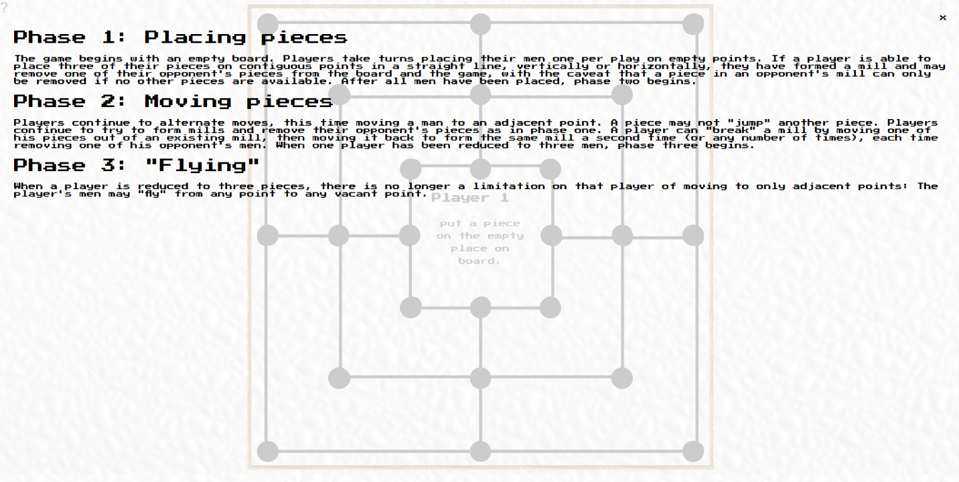

Slika 4 – Pravila “Mica

### 3.1.4 Izgled nakon postavljanja svih figura

Na slici 5. je prikazan izgled stranice kada su postavljene sve figure. U ovom trenutku kreće drugi deo igre.

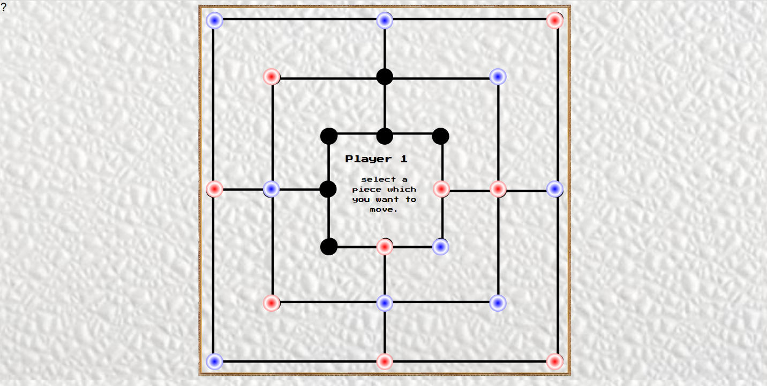

Slika 5 – Stranica nakon postavljenih figura

### 3.1.5 Završetak igre “Mica”

Na slici 6. je prikazana slika završetka igre “Mica”. Pojavljuje se obaveštenje sa igračem koji je pobedio, kao i dugmići za ponovnu igru i odlazak u glavni meni radi odabira igre. Pojavljivanje obaveštenja je takođe u potpunosti odrađeno korišćenjem JavaScript jezika.

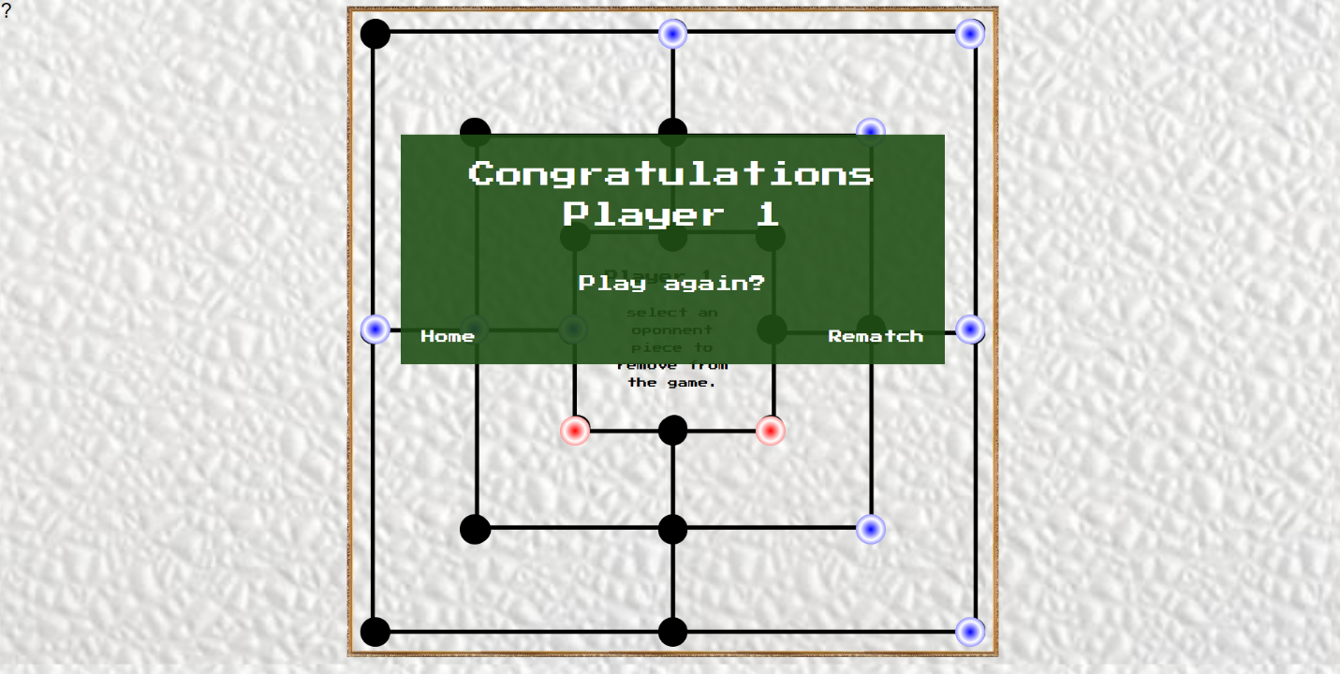

Slika 6 – završetak igre “Mica”

### 3.1.6. Obaveštenje o greški u igri “Mica”

Na slici 7. je prikazana stranica pri pogrešnom korisničkom kliku. Pojavljuje se obaveštenje o greški, koje nestaje nakon nekog vremena, kao i tekst greške.

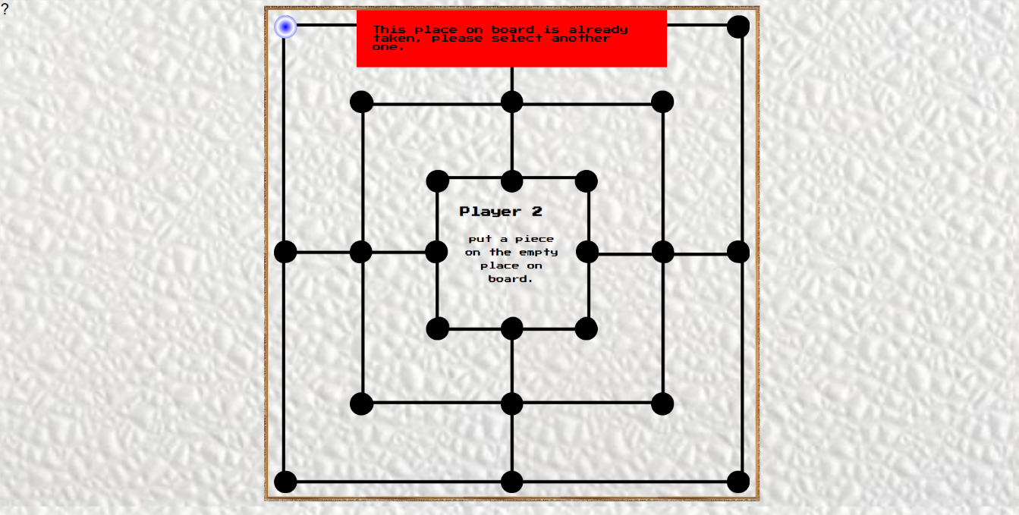

Slika 7 – Prikaz greške u igri “Mica”

### 3.1.7 Inicijalni izgled “Isolation”

Na slici 8. je prikazana stranica sa inicijalnim izgledom igre “Isolation”, kao i u igri “Mica” u gornjem levom uglu se nalazi dugme za prikaz pravila igre, dok se u sredini leve ivice ekrana nalaze podaci o trenutnom potezu, i igrača koji je na potezu

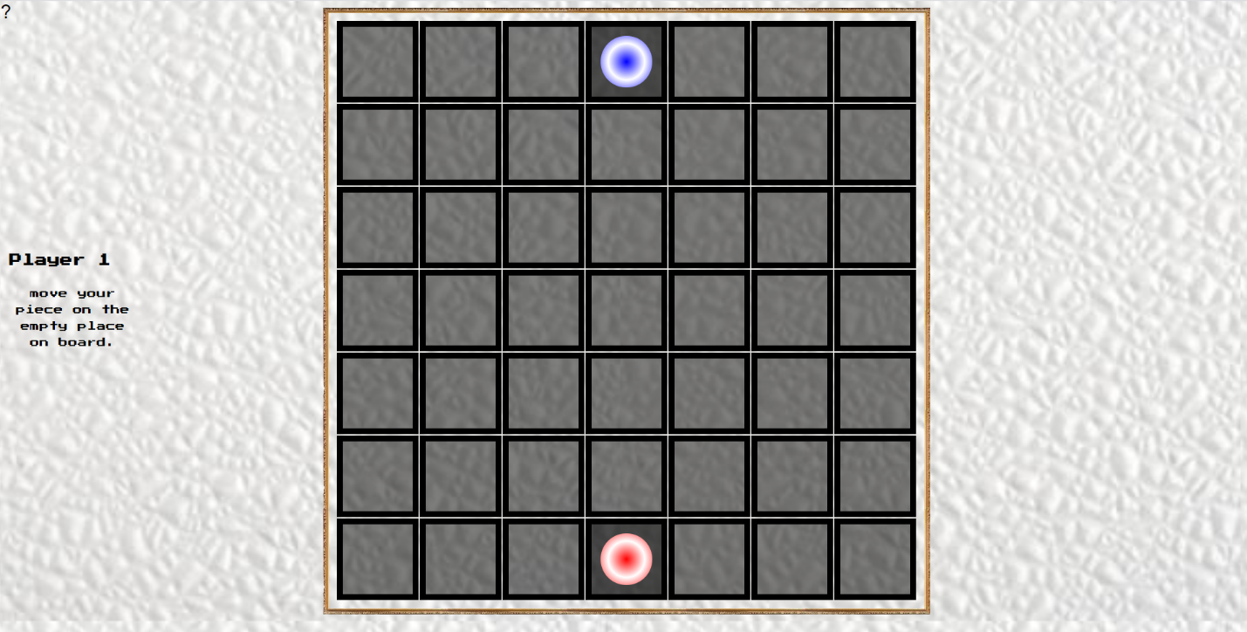

Slika 8 – Prikaz inicijalne postavke igre “Isolation”

### 3.1.8 Pravila igre “Isolation”

Na slici 9. je prikazan izgled stranice o pravilima igre “Isolation”. Klikom na dugme “x” izlazimo iz pravila i nastavljamo igru u trenutku gde smo je ostavili pre otvaranja pravila.

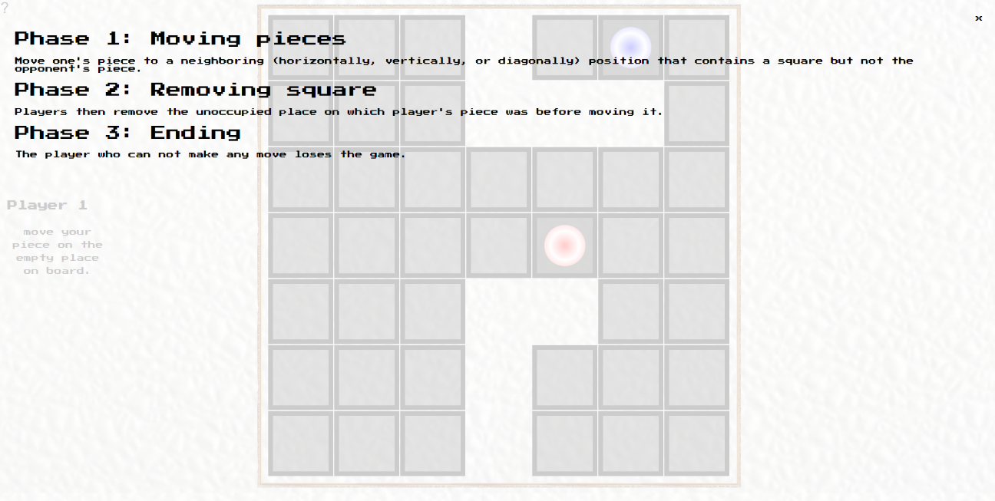

Slika 9 – Pravila igre “Isolation”

### 3.1.9 Završetak igre “Isolation”

Na slici 10. je prikazana slika završetka igre “Isolation”. Pojavljuje se obaveštenje sa igračem koji je pobedio, kao i dugmići za ponovnu igru i odlazak u glavni meni radi odabira igre. Pojavljivanje obaveštenja je takođe u potpunosti odrađeno korišćenjem JavaScript jezika.

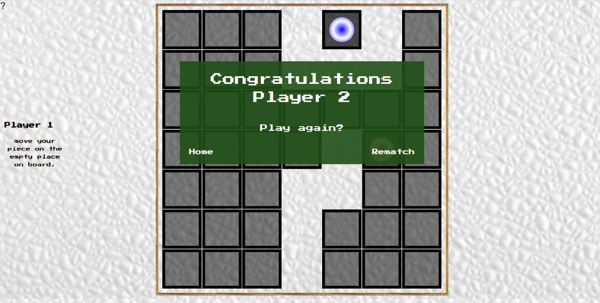

Slika 10 – Prikaz završetka igre “Isolation”

### 3.1.10 Obaveštenje o greški u igri “Isolation”

Na slici 11. je prikazana stranica pri pogrešnom korisničkom kliku. Pojavljuje se obaveštenje o greški, koje nestaje nakon nekog vremena, kao i tekst greške.

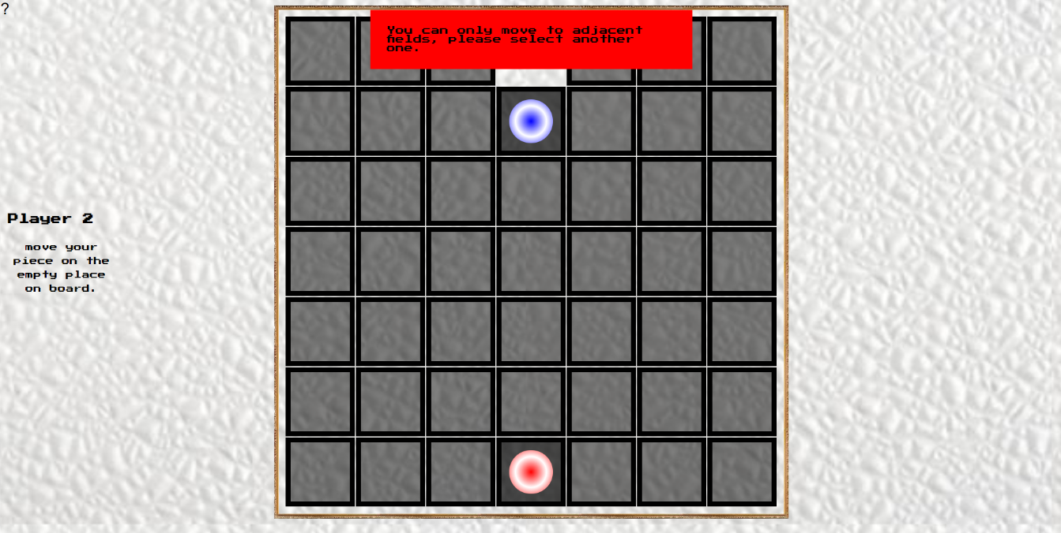

Slika 11 – Greška u igri “Isolation”

# 4. KODOVI

## 4.1 Organizacija:

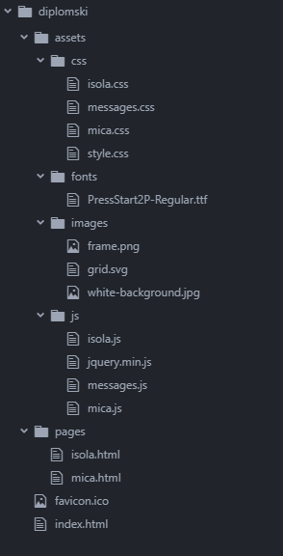

Slika 12 – Struktura fajlova

## 4.2 HTML

### 4.2.1 index.html

<!DOCTYPE html>

<html lang="en">

<head>

<meta charset="utf-8"/>

<title>RarOks Games - Home</title>

<link rel="stylesheet" type="text/css" href="assets/css/style.css"/>

<meta name="viewport" content="width=device-width, initial-scale=1.0"/>

<meta name="keywords" content="games, raroks"/>

<meta name="description" content="Small online javascript games."/>

<meta name="author" content="Nikola Nedeljkovic"/>

<meta name="copyright" content="RarOks 1008 Entertainment @ 2020"/>

<meta name="abstract" content="RarOks JavaScript Games"/>

<meta name="robots" content="index,follow"/>

<link rel="shortcut icon" href="favicon.ico"/>

</head>

<body>

<div class="index_holder">

<h1>RarOks Games</h1>

<ul>

<li><a href="pages/mica.html">Nine Men's Morris</a></li>

<li><a href="pages/isola.html">Isolation</a></li>

<li><a href="http://nikolanedeljkovic.com/">Author</a></li>

</ul>

</div>

</body>

</html>

### 4.2.2 mica.html

<!DOCTYPE html>

<html lang="en">

<head>

<meta charset="utf-8"/>

<title>RG - Nine Men's Morris</title>

<link rel="stylesheet" type="text/css" href="../assets/css/mica.css"/>

<link rel="stylesheet" type="text/css" href="../assets/css/messages.css"/>

<meta name="viewport" content="width=device-width, initial-scale=1.0"/>

<meta name="keywords" content="games, nine, men, morris"/>

<meta name="description" content="Small online javascript game Nine men's morris."/>

<meta name="author" content="Nikola Nedeljkovic"/>

<meta name="copyright" content="RarOks 1008 Entertainment @ 2020"/>

<meta name="abstract" content="RarOks JavaScript Games"/>

<meta name="robots" content="index,follow"/>

<link rel="shortcut icon" href="../favicon.ico"/>

</head>

<body>

<div class="mica_board_holder">

<ul class="mica_board">

<div class="mica_board_row">

<li data-piece="1"></li>

<li data-piece="2"></li>

<li data-piece="3"></li>

</div>

<div class="mica_board_row mica_board_row_second">

<li data-piece="4"></li>

<li data-piece="5"></li>

<li data-piece="6"></li>

</div>

<div class="mica_board_row mica_board_row_third">

<li data-piece="7"></li>

<li data-piece="8"></li>

<li data-piece="9"></li>

</div>

<div class="mica_board_row mica_board_row_forth">

<li data-piece="10"></li>

<li data-piece="11"></li>

<li data-piece="12"></li>

<li class="not_show"></li>

<li data-piece="13"></li>

<li data-piece="14"></li>

<li data-piece="15"></li>

</div>

<div class="mica_board_row mica_board_row_fifth">

<li data-piece="16"></li>

<li data-piece="17"></li>

<li data-piece="18"></li>

</div>

<div class="mica_board_row mica_board_row_second">

<li data-piece="19"></li>

<li data-piece="20"></li>

<li data-piece="21"></li>

</div>

<div class="mica_board_row mica_board_row_last">

<li data-piece="22"></li>

<li data-piece="23"></li>

<li data-piece="24"></li>

</div>

</ul>

</div>

<div class="play_info">

<p class="player_info"></p>

<p class="toplay_info"></p>

</div>

<div class="play_message"></div>

<div class="victory_screen">

<p class="congratulation_text"></p>

<p class="play_again">Play again?</p>

<ul>

<li><a href="../index.html">Home</a></li>

<li><a href="../pages/mica.html">Rematch</a></li>

</ul>

</div>

<button type="button" class="rules_button">?</button>

<div class="rules_holder">

<span class="close_rules">x</span>

<p class="rules_title">Phase 1: Placing pieces</p>

<p class="rules_text">The game begins with an empty board. Players take turns placing their men one per play on empty points. If a player is able to place three of their pieces on contiguous points in a straight line, vertically or horizontally, they have formed a mill and may remove one of their opponent's pieces from the board and the game, with the caveat that a piece in an opponent's mill can only be removed if no other pieces are available. After all men have been placed, phase two begins.</p>

<p class="rules_title">Phase 2: Moving pieces</p>

<p class="rules_text">Players continue to alternate moves, this time moving a man to an adjacent point. A piece may not "jump" another piece. Players continue to try to form mills and remove their opponent's pieces as in phase one. A player can "break" a mill by moving one of his pieces out of an existing mill, then moving it back to form the same mill a second time (or any number of times), each time removing one of his opponent's men. When one player has been reduced to three men, phase three begins.</p>

<p class="rules_title">Phase 3: "Flying"</p>

<p class="rules_text">When a player is reduced to three pieces, there is no longer a limitation on that player of moving to only adjacent points: The player's men may "fly" from any point to any vacant point.</p>

</div>

<script src="../assets/js/jquery.min.js"></script>

<script src="../assets/js/mica.js"></script>

<script src="../assets/js/messages.js"></script>

</body>

</html>

### 4.2.3 isola.html

<!DOCTYPE html>

<html lang="en">

<head>

<meta charset="utf-8"/>

<title>RG - Isolation</title>

<link rel="stylesheet" type="text/css" href="../assets/css/isola.css"/>

<link rel="stylesheet" type="text/css" href="../assets/css/messages.css"/>

<meta name="viewport" content="width=device-width, initial-scale=1.0"/>

<meta name="keywords" content="games, isola, isolation, javascript"/>

<meta name="description" content="Small online javascript game Isolation."/>

<meta name="author" content="Nikola Nedeljkovic"/>

<meta name="copyright" content="RarOks 1008 Entertainment @ 2020"/>

<meta name="abstract" content="RarOks JavaScript Games"/>

<meta name="robots" content="index,follow"/>

<link rel="shortcut icon" href="../favicon.ico"/>

</head>

<body>

<div class="isola_board_holder">

<table class="isola_board">

<tr>

<td data-piece="1"><div></div></td>

<td data-piece="2"><div></div></td>

<td data-piece="3"><div></div></td>

<td data-piece="4" class="standing player1"><div></div></td>

<td data-piece="5"><div></div></td>

<td data-piece="6"><div></div></td>

<td data-piece="7"><div></div></td>

</tr>

<tr>

<td data-piece="8"><div></div></td>

<td data-piece="9"><div></div></td>

<td data-piece="10"><div></div></td>

<td data-piece="11"><div></div></td>

<td data-piece="12"><div></div></td>

<td data-piece="13"><div></div></td>

<td data-piece="14"><div></div></td>

</tr>

<tr>

<td data-piece="15"><div></div></td>

<td data-piece="16"><div></div></td>

<td data-piece="17"><div></div></td>

<td data-piece="18"><div></div></td>

<td data-piece="19"><div></div></td>

<td data-piece="20"><div></div></td>

<td data-piece="21"><div></div></td>

</tr>

<tr>

<td data-piece="22"><div></div></td>

<td data-piece="23"><div></div></td>

<td data-piece="24"><div></div></td>

<td data-piece="25"><div></div></td>

<td data-piece="26"><div></div></td>

<td data-piece="27"><div></div></td>

<td data-piece="28"><div></div></td>

</tr>

<tr>

<td data-piece="29"><div></div></td>

<td data-piece="30"><div></div></td>

<td data-piece="31"><div></div></td>

<td data-piece="32"><div></div></td>

<td data-piece="33"><div></div></td>

<td data-piece="34"><div></div></td>

<td data-piece="35"><div></div></td>

</tr>

<tr>

<td data-piece="36"><div></div></td>

<td data-piece="37"><div></div></td>

<td data-piece="38"><div></div></td>

<td data-piece="39"><div></div></td>

<td data-piece="40"><div></div></td>

<td data-piece="41"><div></div></td>

<td data-piece="42"><div></div></td>

</tr>

<tr>

<td data-piece="43"><div></div></td>

<td data-piece="44"><div></div></td>

<td data-piece="45"><div></div></td>

<td data-piece="46" class="standing player2"><div></div></td>

<td data-piece="47"><div></div></td>

<td data-piece="48"><div></div></td>

<td data-piece="49"><div></div></td>

</tr>

</table>

</div>

<div class="play_info">

<p class="player_info"></p>

<p class="toplay_info"></p>

</div>

<div class="play_message"></div>

<div class="victory_screen">

<p class="congratulation_text"></p>

<p class="play_again">Play again?</p>

<ul>

<li><a href="../index.html">Home</a></li>

<li><a href="../pages/isola.html">Rematch</a></li>

</ul>

</div>

<button type="button" class="rules_button">?</button>

<div class="rules_holder">

<span class="close_rules">x</span>

<p class="rules_title">Phase 1: Moving pieces</p>

<p class="rules_text">Move one's piece to a neighboring (horizontally, vertically, or diagonally) position that contains a square but not the opponent's piece.</p>

<p class="rules_title">Phase 2: Removing square</p>

<p class="rules_text">Players then remove the unoccupied place on which player's piece was before moving it.</p>

<p class="rules_title">Phase 3: Ending</p>

<p class="rules_text">The player who can not make any move loses the game.</p>

</div>

<script src="../assets/js/jquery.min.js"></script>

<script src="../assets/js/isola.js"></script>

<script src="../assets/js/messages.js"></script>

</body>

</html>

## 4.3 CSS

### 4.3.1 style.css

@font-face {

font-family: PressStart2P;

src: url(../fonts/PressStart2P-Regular.ttf);

}

* {

margin: 0;

padding: 0;

box-sizing: border-box;

}

body {

font-family: PressStart2P;

background-image: url('../images/white-background.jpg');

background-size: cover;

}

.index_holder {

display: flex;

flex-direction: column;

align-items: center;

}

.index_holder h1 {

text-align: center;

font-size: 50px;

margin-top: 50px;

margin-bottom: 30px;

}

.index_holder ul {

list-style-type: none;

}

.index_holder ul li {

text-align: center;

border: 10px solid #675041;

border-image: url('../images/frame.png') 10 round;

margin-top: 40px;

padding: 20px 10px;

}

.index_holder ul li a {

color: black;

text-decoration: none;

}

.index_holder ul li a:hover {

color: #f9a620;

}

### 4.3.2. messages.css

@font-face {

font-family: PressStart2P;

src: url(../fonts/PressStart2P-Regular.ttf);

}

.play_info {

font-family: PressStart2P;

position: absolute;

}

.play_info .player_info {

margin-top: 1vh;

font-size: 2vh;

font-weight: bold;

}

.play_info .toplay_info {

text-align: center;

margin-top: 3vh;

line-height: 2.6vh;

font-size: 1.5vh;

}

.play_message {

font-family: PressStart2P;

position: absolute;

top: 2vh;

left: calc(50% - 30vh);

width: 60vh;

padding: 3vh;

background-color: red;

display: none;

}

.play_message.show_message {

display: flex;

}

.victory_screen {

font-family: PressStart2P;

position: absolute;

width: 80vh;

top: 20vh;

left: calc(50% - 40vh);

background-color: rgba(32, 79, 21, 0.9);

padding: 3vh;

color: #ffffff;

display: none;

}

.victory_screen .congratulation_text {

font-size: 4vh;

line-height: 6vh;

text-align: center;

}

.victory_screen .play_again {

font-size: 2.5vh;

line-height: 6vh;

text-align: center;

margin-top: 4vh;

}

.victory_screen ul {

margin-top: 4vh;

list-style-type: none;

display: flex;

justify-content: space-between;

}

.victory_screen ul li a {

text-decoration: none;

color: #ffffff;

font-size: 2vh;

}

.victory_screen ul li a:hover {

color: #f9a620;

}

.victory_screen.show_screen {

display: flex;

flex-direction: column;

}

.rules_button {

position: absolute;

top: 0.1vh;

left: 0.1vh;

border: none;

background-color: transparent;

font-size: 3vh;

border-radius: 50%;

cursor: pointer;

}

.rules_button:hover {

opacity: 0.7;

}

.rules_button:focus {

outline: none;

}

.rules_holder {

font-family: PressStart2P;

position: absolute;

top: 0;

width: 100%;

height: 100vh;

padding: 3vh;

display: none;

flex-direction: column;

background-color: rgba(255, 255, 255, 0.8);

}

.rules_holder .close_rules {

align-self: flex-end;

cursor: pointer;

user-select: none;

font-size: 1.5vh;

}

.rules_holder .rules_title {

font-size: 3vh;

margin-bottom: 2vh;

margin-top: 2vh;

}

.rules_holder .rules_text {

font-size: 1.5vh;

}

.rules_holder.show_rules {

display: flex;

flex-direction: column;

}

### 4.3.3. mica.css

* {

margin: 0;

padding: 0;

box-sizing: border-box;

}

body {

background-image: url('../images/white-background.jpg');

background-size: contain;

}

.mica_board_holder {

height: 96vh;

width: 96vh;

margin: 1vh auto;

padding: 1vh;

border: 1vh solid #675041;

border-image: url('../images/frame.png') 10 round;

}

.mica_board {

width: 100%;

height: 100%;

background-image: url('../images/grid.svg');

background-repeat: no-repeat;

background-size: contain;

list-style-type: none;

}

.mica_board_row {

width: 100%;

height: 10vh;

display: flex;

justify-content: space-between;

}

.mica_board_row_second {

margin-left: 2.5%;

margin-top: 4.5vh;

width: 95%;

justify-content: space-around;

}

.mica_board_row_third {

margin-left: 26.5%;

margin-top: 5.4vh;

width: 47%;

justify-content: space-around;

}

.mica_board_row_forth {

margin-top: 3.6vh;

justify-content: space-between;

}

.mica_board_row_fifth {

margin-left: 26.5%;

margin-top: 5vh;

width: 47%;

justify-content: space-around;

}

.mica_board_row_last {

margin-top: 5.1vh;

height: auto;

}

.mica_board .mica_board_row li {

width: 4.4vh;

height: 4.4vh;

border-radius: 50%;

background-color: #000000;

cursor: pointer;

}

.mica_board .mica_board_row li.not_show {

opacity: 0;

cursor: default;

}

.mica_board .mica_board_row li.player1 {

background-image: radial-gradient(circle, #0000ff, #ffffff, #0000ff);

background-color: #0000ff;

}

.mica_board .mica_board_row li.player2 {

background-image: radial-gradient(circle, #ff0000, #ffffff, #ff0000);

background-color: #ff0000;

}

.play_info {

top: calc(50% - 12vh);

left: calc(50% - 11vh);

width: 22vh;

height: 22vh;

padding: 1vh;

}

### 4.3.4. isola.css

* {

margin: 0;

padding: 0;

box-sizing: border-box;

}

body {

background-image: url('../images/white-background.jpg');

background-size: contain;

}

.isola_board_holder {

height: 96vh;

width: 96vh;

margin: 1vh auto;

padding: 1vh;

border: 1vh solid #675041;

border-image: url('../images/frame.png') 10 round;

}

.isola_board {

width: 100%;

height: 100%;

background-repeat: no-repeat;

background-size: contain;

list-style-type: none;

}

.isola_board tr td {

border: 1vh solid #000000;

background-color: rgba(0, 0, 0, 0.5);

cursor: pointer;

}

.isola_board tr td.standing {

background-color: rgba(0, 0, 0, 0.7);

cursor: default;

}

.isola_board tr td.dropped {

background-color: transparent;

border: 1vh solid rgba(255, 255, 255, 0);

cursor: default;

}

.isola_board tr .standing.player1 div, .isola_board tr .standing.player2 div {

width: 75%;

height: 75%;

margin-left: 12.5%;

border-radius: 50%;

}

.isola_board tr .standing.player1 div {

background-image: radial-gradient(circle, #0000ff, #ffffff, #0000ff);

background-color: #0000ff;

}

.isola_board tr .standing.player2 div {

background-image: radial-gradient(circle, #ff0000, #ffffff, #ff0000);

background-color: #ff0000;

}

.play_info {

top: calc(50% - 12vh);

left: 0.5vh;

width: 22vh;

padding: 1vh;

}

## 4.4 JAVASCRIPT

### 4.3.1 messages.js

function fill_player_info (player, status) {

var player_text = player == "player1" ? "Player 1" : "Player 2";

$(".player_info").html(player_text);

$(".toplay_info").html(status);

}

function player_notification(message) {

var opacity = 1;

$(".play_message").html(message);

$(".play_message").css("opacity", opacity);

$(".play_message").addClass("show_message");

setTimeout( function () {

var opacity_interval = setInterval(function() {

if (opacity <= 0) {

clearInterval(opacity_interval);

$(".play_message").removeClass("show_message");

}

$(".play_message").css("opacity", opacity);

opacity -= 0.1;

}, 100);

}, 3000);

}

function declare_endgame(winner) {

var cong_text = "Congratulations " + (winner == "player1" ? "Player 1" : "Player 2");

$(".victory_screen .congratulation_text").html(cong_text)

$(".victory_screen").addClass("show_screen");

}

function rules_clicked() {

$(".rules_holder").addClass("show_rules");

$(".rules_holder .close_rules").on("click", function () {

$(".rules_holder").removeClass("show_rules");

});

}

### 4.3.2 mica.js

var PIECES_COMBINATIONS = [

[1, 2, 3], [1, 10, 22], [2, 5, 8], [3, 15, 24], [4, 5, 6], [4, 11, 19], [6, 14, 21], [7, 8, 9], [7, 12, 16],

[9, 13, 18], [10, 11, 12], [13, 14, 15], [16, 17, 18], [17, 20, 23], [19, 20, 21], [22, 23, 24]

],

PIECE_PAIRS = [

[1, 2], [1, 10], [2, 3], [2, 5], [3, 15], [4, 5], [4, 11], [5, 6], [5, 8], [6, 14], [7, 8], [7, 12], [8, 9],

[9, 13], [10, 11], [10, 22], [11, 12], [11, 19], [12, 16], [13, 14], [13, 18], [14, 15], [14, 21], [15, 24],

[16, 17], [17, 18], [17, 20], [19, 20], [20, 21], [20, 23], [22, 23], [23, 24]

],

NUMBER_PIECES = 18,

current_player = 'player1',

player1_pieces = [],

player2_pieces = [],

number_played = 0;

$(document).ready(function() {

place_pieces();

$(".rules_button").on("click", rules_clicked);

});

function place_pieces() {

if (number_played == NUMBER_PIECES) { start_moving(); return; }

fill_player_info(current_player, "put a piece on the empty place on board.");

$(".mica_board li").on("click", function() {

var clicked_piece = $(this).attr("data-piece");

if (player1_pieces.indexOf(parseInt(clicked_piece)) >= 0 ||

player2_pieces.indexOf(parseInt(clicked_piece)) >= 0) {

player_notification("This place on board is already taken, please select another one.");

$(".mica_board li").off();

place_pieces();

} else {

if (current_player == "player1") { player1_pieces.push(parseInt(clicked_piece)); }

if (current_player == "player2") { player2_pieces.push(parseInt(clicked_piece)); }

number_played += 1;

$(this).addClass(current_player);

if (current_player == "player1") {

current_player = "player2";

} else {

current_player = "player1";

}

$(".mica_board li").off();

check_placed_three(current_player, clicked_piece, place_pieces);

}

});

}

function check_placed_three(player, clicked_piece, when_done) {

var real_player_pieces = player == "player1" ? player2_pieces : player1_pieces,

opponent_pieces = player == "player2" ? player2_pieces : player1_pieces,

class_name = ".mica_board li." + player;

if (real_player_pieces.length < 3) { when_done(); return; }

var found_combination = three_in_row(real_player_pieces, clicked_piece);

if (found_combination) {

fill_player_info(current_player == "player1" ? "player2" : "player1", "select an oponnent piece to remove from the game.");

$(class_name).on("click", function() {

var all_three = true,

clicked_num = $(this).attr("data-piece");

opponent_pieces.forEach((pc) => {

all_three = all_three && three_in_row(opponent_pieces, pc);

});

if (!all_three && three_in_row(opponent_pieces, clicked_num)) {

player_notification("You can not remove an enemy piece which is in a mill.");

return;

}

$(this).removeClass(player);

if (player == "player1") {

player1_pieces.splice(player1_pieces.indexOf(parseInt(clicked_num)), 1);

} else {

player2_pieces.splice(player2_pieces.indexOf(parseInt(clicked_num)), 1);

}

$(".mica_board li").off();

when_done();

});

} else {

when_done();

}

}

function three_in_row(which_pieces, clicked_piece) {

var i, j, k,

found = false;

for (i = 0; i < which_pieces.length - 2; i++) {

for (j = i + 1; j < which_pieces.length - 1; j++) {

for (k = j + 1; k < which_pieces.length; k++) {

PIECES_COMBINATIONS.forEach((comb) => {

if (found) { return; }

var fp = which_pieces[i],

sp = which_pieces[j],

tp = which_pieces[k];

if (comb.indexOf(fp) >= 0 && comb.indexOf(sp) >= 0 && comb.indexOf(tp) >= 0 &&

(fp == clicked_piece || sp == clicked_piece || tp == clicked_piece)) {

found = true;

}

});

}

}

}

return found;

}

function start_moving() {

if (player1_pieces.length < 3 || player2_pieces.length < 3) {

declare_endgame(current_player == "player1" ? "player2" : "player1");

return;

}

var real_player = current_player == "player1" ? player1_pieces : player2_pieces,

class_name = ".mica_board li." + current_player,

movable = check_possible_moves(real_player);

if (!movable && real_player.length != 3) {

declare_endgame(current_player == "player1" ? "player2" : "player1");

}

fill_player_info(current_player, "select a piece which you want to move.");

$(class_name).on("click", function() {

var current_clicked = $(this).attr("data-piece"),

exists_move = false,

current_element = $(this);

PIECE_PAIRS.forEach((pair) => {

if (exists_move) { return; }

if (pair.indexOf(parseInt(current_clicked)) < 0) { return; }

var second_pair;

if (pair[0] == parseInt(current_clicked)) {

second_pair = pair[1];

} else {

second_pair = pair[0];

}

exists_move = player1_pieces.indexOf(second_pair) < 0 && player2_pieces.indexOf(second_pair) < 0;

});

if (!exists_move && real_player.length != 3) {

player_notification("This piece can not be moved, please select another one to move.");

return;

}

$(".mica_board li").off();

fill_player_info(current_player, real_player.length == 3 ? "select any non-occupied place to move to." :

"select an adjacent non-occupied place to move to.");

$(".mica_board li").on("click", function() {

var curr_click = $(this).attr("data-piece"),

is_legit_move = false,

curr_el = $(this);

if (player1_pieces.indexOf(parseInt(curr_click)) >= 0 ||

player2_pieces.indexOf(parseInt(curr_click)) >= 0) {

player_notification("You can not move to a taken place, please select another one.");

$(".mica_board li").off();

start_moving();

return;

}

PIECE_PAIRS.forEach((pr) => {

if (is_legit_move) { return; }

if (pr.indexOf(parseInt(current_clicked)) < 0) { return; }

if (pr.indexOf(parseInt(curr_click)) < 0) { return; }

is_legit_move = true;

});

if (!is_legit_move && real_player.length != 3) {

player_notification("You can only move to an adjacent place, please select another one.");

$(".mica_board li").off();

start_moving();

return;

}

current_element.removeClass(current_player);

curr_el.addClass(current_player);

if (current_player == "player1") {

player1_pieces.splice(player1_pieces.indexOf(parseInt(current_clicked)), 1);

player1_pieces.push(parseInt(curr_click));

} else {

player2_pieces.splice(player2_pieces.indexOf(parseInt(current_clicked)), 1);

player2_pieces.push(parseInt(curr_click));

}

if (current_player == "player1") {

current_player = "player2";

} else {

current_player = "player1";

}

$(".mica_board li").off();

check_placed_three(current_player, curr_click, start_moving);

});

});

}

function check_possible_moves(pl) {

var mv = false;

pl.forEach((p) => {

if (mv) { return; }

PIECE_PAIRS.forEach((pair) => {

if (mv) { return; }

if (pair.indexOf(parseInt(p)) < 0) { return; }

var second_pair;

if (pair[0] == parseInt(p)) {

second_pair = pair[1];

} else {

second_pair = pair[0];

}

mv = player1_pieces.indexOf(second_pair) < 0 && player2_pieces.indexOf(second_pair) < 0;

});

});

return mv;

}

### 4.3.3 isola.js

var PIECE_PAIRS = [

[1, 2], [1, 8], [1, 9], [2, 3], [2, 8], [2, 9], [2, 10], [3, 4], [3, 9], [3, 10], [3, 11],

[4, 5], [4, 10], [4, 11], [4, 12], [5, 6], [5, 11], [5, 12], [5, 13], [6, 7], [6, 12], [6, 13], [6, 14],

[7, 13], [7, 14], [8, 9], [8, 15], [8, 16], [9, 10], [9, 15], [9, 16], [9, 17], [10, 11], [10, 16], [10, 17], [10, 18],

[11, 12], [11, 17], [11, 18], [11, 19], [12, 13], [12, 18], [12, 19], [12, 20], [13, 14], [13, 19], [13, 20], [13, 21],

[14, 20], [14, 21], [15, 16], [15, 22], [15, 23], [16, 17], [16, 22], [16, 23], [16, 24], [17, 18], [17, 23], [17, 24],

[17, 25], [18, 19], [18, 24], [18, 25], [18, 26], [19, 20], [19, 25], [19, 26], [19, 27], [20, 21], [20, 26], [20, 27],

[20, 28], [21, 27], [21, 28], [22, 23], [22, 29], [22, 30], [23, 24], [23, 29], [23, 30], [23, 31], [24, 25], [24, 30],

[24, 31], [24, 32], [25, 26], [25, 31], [25, 32], [25, 33], [26, 27], [26, 32], [26, 33], [26, 34], [27, 28], [27, 33],

[27, 34], [27, 35], [28, 34], [28, 35], [29, 30], [29, 36], [29, 37], [30, 31], [30, 36], [30, 37], [30, 38], [31, 32],

[31, 37], [31, 38], [31, 39], [32, 33], [32, 38], [32, 39], [32, 40], [33, 34], [33, 39], [33, 40], [33, 41], [34, 35],

[34, 40], [34, 41], [34, 42], [35, 41], [35, 42], [36, 37], [36, 43], [36, 44], [37, 38], [37, 43], [37, 44], [37, 45],

[38, 39], [38, 44], [38, 45], [38, 46], [39, 40], [39, 45], [39, 46], [39, 47], [40, 41], [40, 46], [40, 47], [40, 48],

[41, 42], [41, 47], [41, 48], [41, 49], [42, 48], [42, 49], [43, 44], [44, 45], [45, 46], [46, 47], [47, 48], [48, 49]

],

current_player = 'player1',

player1_piece = 4,

player2_piece = 46,

pieces_removed = [];

$(document).ready(function() {

start_moving_pieces();

$(".rules_button").on("click", rules_clicked);

});

function start_moving_pieces() {

fill_player_info(current_player, "move your piece on the empty place on board.");

var real_player = current_player == "player1" ? player1_piece : player2_piece,

other_player = current_player == "player1" ? player2_piece : player1_piece,

movable = check_possible_moves(real_player, other_player);

if (!movable) { declare_endgame(current_player == "player1" ? "player2" : "player1"); }

$(".isola_board tr td").on("click", function() {

var clicked_piece = $(this).attr("data-piece"),

clicked_piece_whole = $(this);

if (pieces_removed.indexOf(parseInt(clicked_piece)) >= 0 ||

player1_piece == parseInt(clicked_piece) || player2_piece == parseInt(clicked_piece)) {

player_notification("This place on board is already taken or removed, please select another one.");

$(".isola_board tr td").off();

start_moving_pieces();

} else {

var can_move = false;

PIECE_PAIRS.forEach((pair) => {

if (can_move) { return; }

if (pair.indexOf(parseInt(clicked_piece)) >= 0 && pair.indexOf(real_player) >= 0) {

can_move = true;

}

});

if (!can_move) {

player_notification("You can only move to adjacent fields, please select another one.");

$(".isola_board tr td").off();

start_moving_pieces();

} else {

var classname = "." + current_player;

pieces_removed.push(parseInt($(classname).attr("data-piece")));

$(classname).removeClass("standing").removeClass(current_player).addClass("dropped");

clicked_piece_whole.addClass("standing").addClass(current_player);

if (current_player == "player1") { player1_piece = parseInt(clicked_piece); }

if (current_player == "player2") { player2_piece = parseInt(clicked_piece); }

current_player = current_player == "player1" ? "player2" : "player1";

$(".isola_board tr td").off();

start_moving_pieces();

}

}

});

}

function check_possible_moves(pl, op) {

var mv = false;

PIECE_PAIRS.forEach((pair) => {

if (mv) { return; }

if ((pair[0] == pl && (pieces_removed.indexOf(pair[1]) < 0 && pair[1] != op))

|| (pair[1] == pl && (pieces_removed.indexOf(pair[0]) < 0 && pair[0] != op))) {

mv = true;

}

});

return mv;

}

# 6. ZAKLJUČAK

Web stranica za interaktivne igre “Mica” i “Isolation” nastala je kao ideja lakšeg igranja starih igara na Internetu. U te svrhe odabrane su dve igre, jedna poznatija na našijim prostorima, a druga i ne toliko poznata, za koju i nakon dužeg traženja prevoda na srpski jezik, nije nađen ni jedan idealan prevod. S ciljem prikazivanja raznih igara svakom korisniku, uz sva objašnjenja i sve moguće izlaze predviđene, igre su optimizovane i najneiskusnijim igračima i neigračima.

Stranica je otvorenog tipa I svaki neautorizovani korisnik može pristupiti glavnoj, početnoj stranici i svakoj igri koju odabere. Nije uvežena ni analitika, ni praćenje ni čuvanje podataka, I jedini cilj je zabava krajnjeg korisnika. Korisnik može videti sadržaj potez drugog igrača, može videte na kom koraku u igri je stigao svaki igrač, i u svakom trenutku otvoriti pravila radi lakšeg podsećanja igre, bez straha o mogućem eventualnom gubitku progresa igre. Odabrane boje i nijanse su s namerom izabrane kao što jesu, radi najlakšeg i najboljeg iskustva korisnika u igri.

U igri “Mica” s namerom nije sve u potpunosti poravnato, u nadi da će se i u samom ne-centralizovanom mestu za igru, korisniku učiniti kao da stvarno igra svojim rukama, a ne mišom ili dodirnom tablom.

Promene nad sajtom se mogu vršiti van samog okruženja sajta, što umnogome umanjuje mogućnost za greškom i neki slučajan klik korisnika koji bi obrisao neki deo sajta.

# 7. LITERATURA

1. Dr Nenad Kojić, Web Dizajn, Visoka škola za informacione I komunikacione tehnologije Beograd, 2017.
2. Dr Nenad Kojić, Web Programiranje, Visoka škola za informacione I komunikacione tehnologije Beograd, 2017.
3. <http://webdizajn.ict.edu.rs/>
4. <http://www.w3schools.com/>
5. <http://stackoverflow.com/>
6. http://developer.mozilla.org/